**Quadrat Sampling Problems**

Sample Problem: A biologist wants to estimate the population size and density of snails on a beach. The beach measures 100 m by 50 m. The biologist randomly places four 1m by 1m quadrats on the beach. Estimate the population size and density of the biologist counts 55, 13, 42, and 35 snails in the four quadrats.

Average density of sampled quadrats:

$$D=\frac{number of individuals}{sampling area}$$

Estimated population size:

$$N=\left(estimated population density\right)\left(total size of study area\right)$$

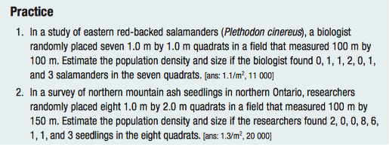

**Mark and Recapture Sampling Problems**

* Formula:

$$N=\frac{Mn}{m}$$ where N = estimate of the total population size

M = total number of animals marked on first visit

n = total number of animals recaptured on second visit

m = number of marked animals that were recaptured on the second visit

Sample Problem:

Biologists were studying a saw-whet owl population of unknown size. They captured, banded, and released 30 individuals. They waited until they assumed that the released individuals had moved randomly through the population. Then they captured a second sample of 80 individuals and found that 12 individuals were marked. Use these values to estimate the population size.

